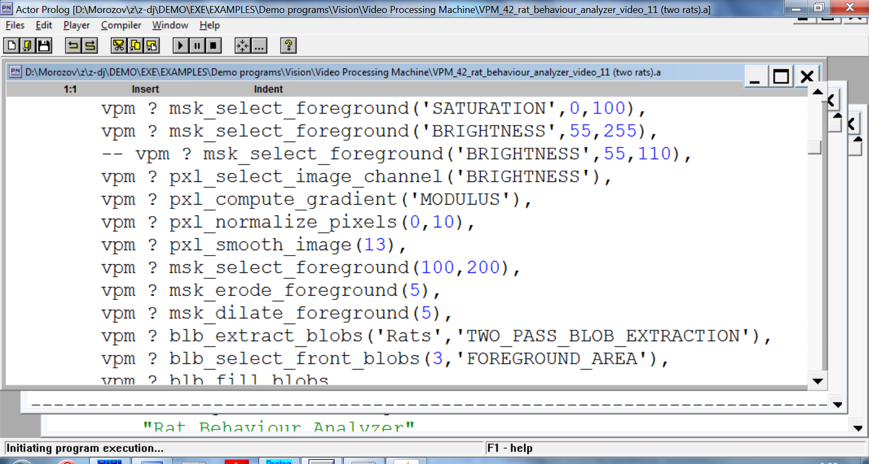 |  |  | 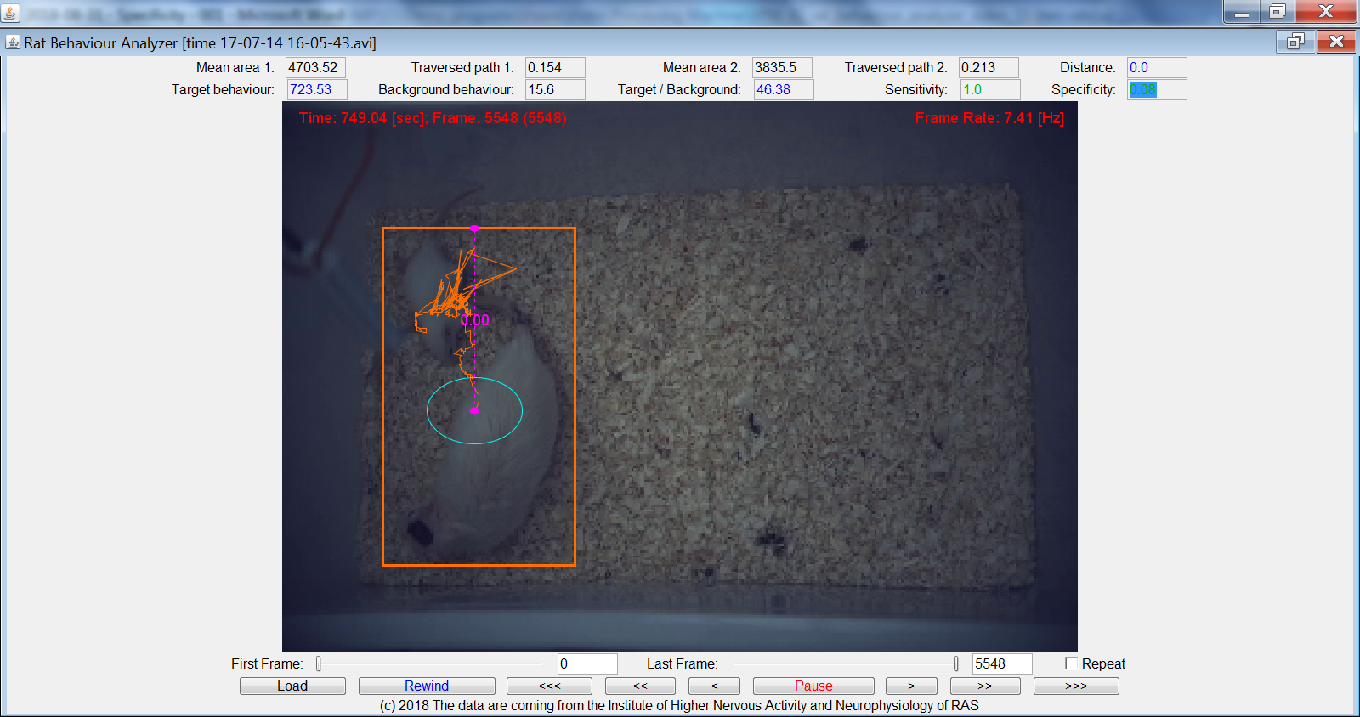
4703.52 | 0.154 | 3835.5 |  | 0.213 | 0.0
723.53 | 15.6 | 46.38 |  | 1.0 | 0.08

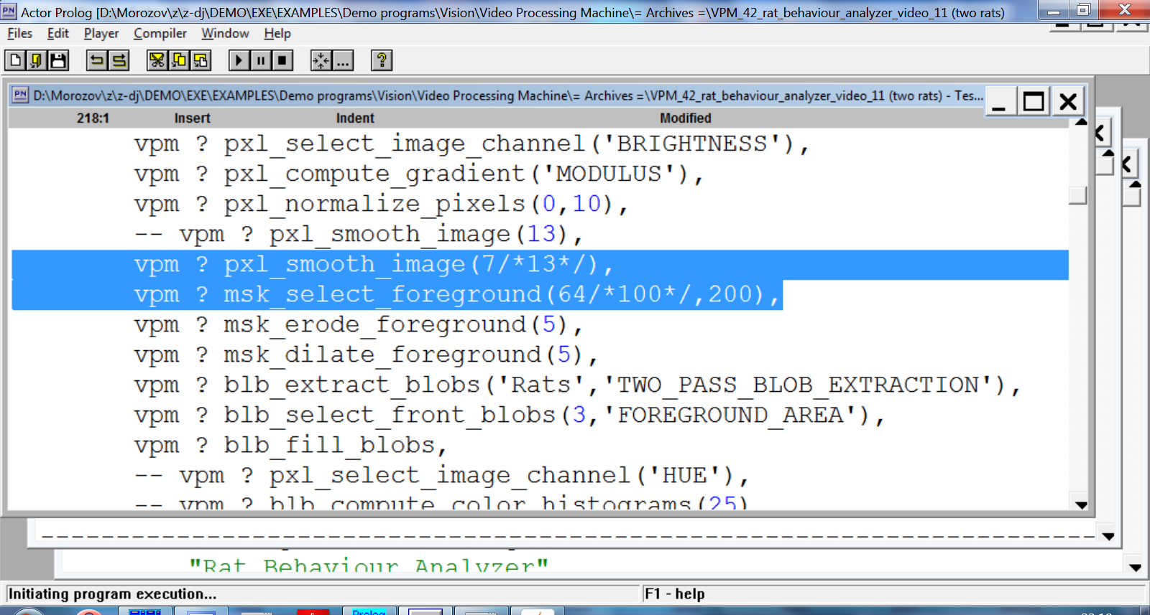 |  |  | 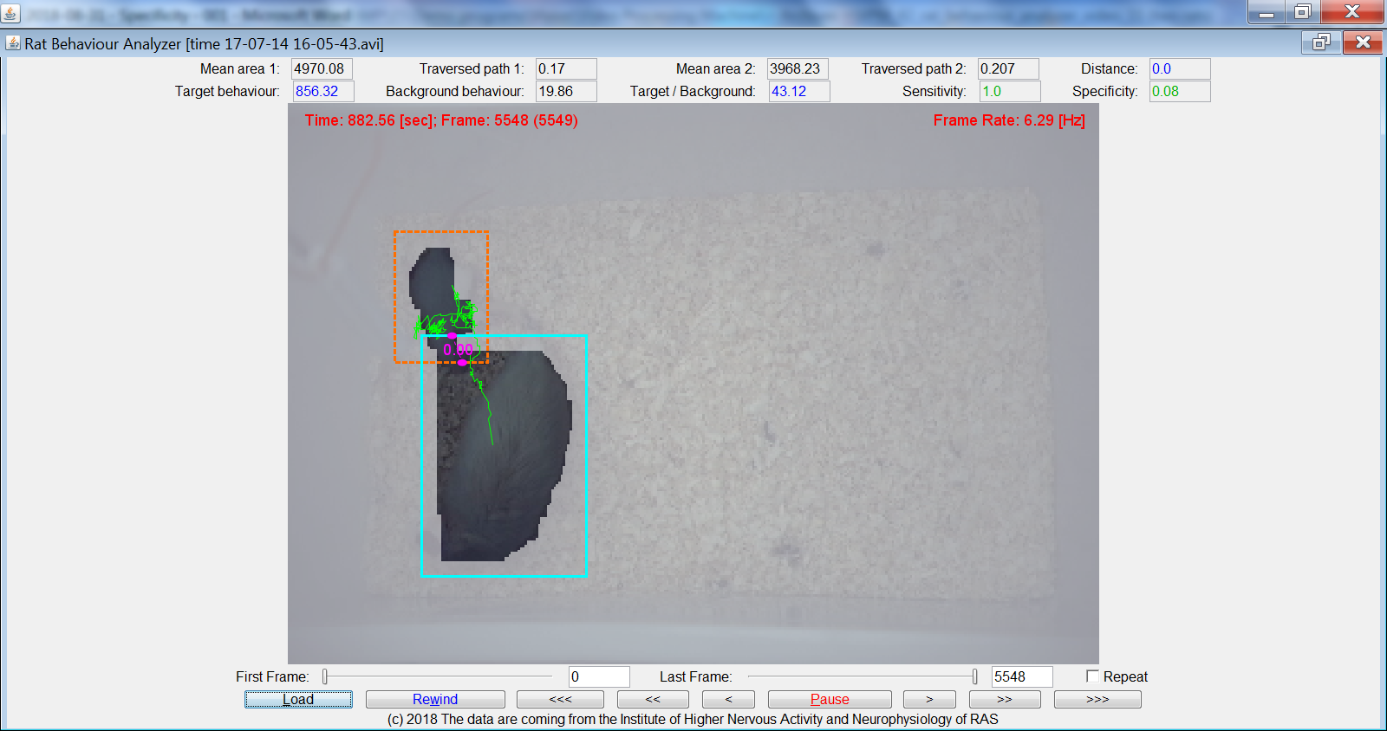
4970.08 | 0.17 | 3968.23 |  | 0.207 | 0.0
856.32 | 19.86 | 43.12 |  | 1.0 | 0.08
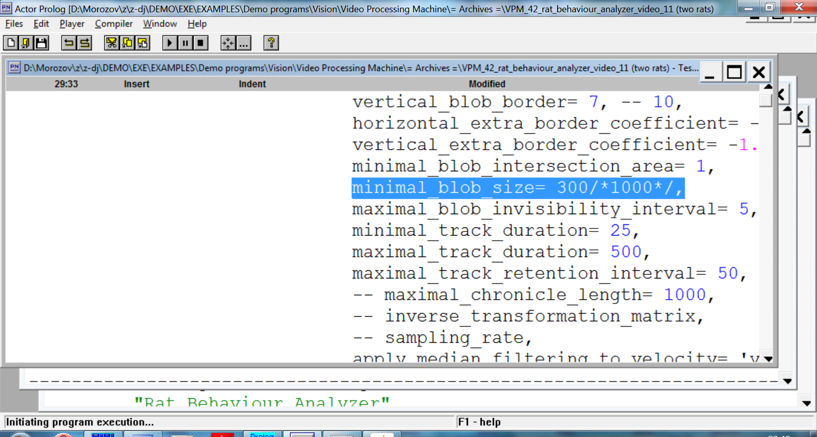  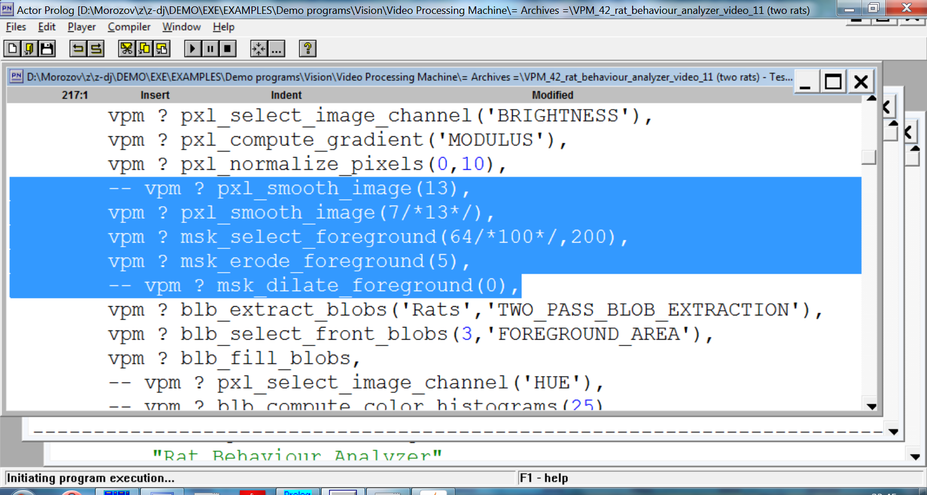 |  |  | 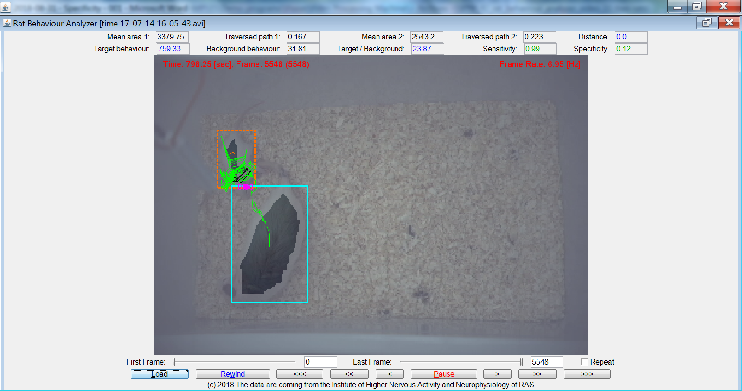
3379.75 | 0.167 | 2543.2 |  | 0.223 | 0.0
759.33 | 31.81 | 23.87 |  | 0.99 | 0.12

